ReactJS HOL-3 Solution

CalculateScore.js
import "./Stylesheets/mystyle.css";
const percentToDecimal=(d)=>d.toFixed(2)+"%";
const calcScore=(total,goal)=>percentToDecimal(total/goal);
export default function CalculateScore({Name,School,total,goal}){
return(
<div className="formatstyle">
<h1><font color="brown">Student Details:</font></h1>
<div className="Name"><b>Name:</b> {Name}</div>
<div className="School"><b>School:</b> {School}</div>
<div className="Total"><b>Total:</b> {total} Marks</div>
<div className="Score"><b>Score:</b> {calcScore(total,goal)}</div>
</div>
);
}

mystyle.css
.Name{font-weight:300;color:blue;}
.School{color:crimson;}
.Total{color:darkmagenta;}
.Score{color:forestgreen;}
.formatstyle{text-align:center;font-size:large;}

App.js
import CalculateScore from "./Components/CalculateScore";
function App(){
return(
<CalculateScore Name="Steve"
School="DNV Public School"
total={284}
goal={3}/>
);
}
export default App;

Output
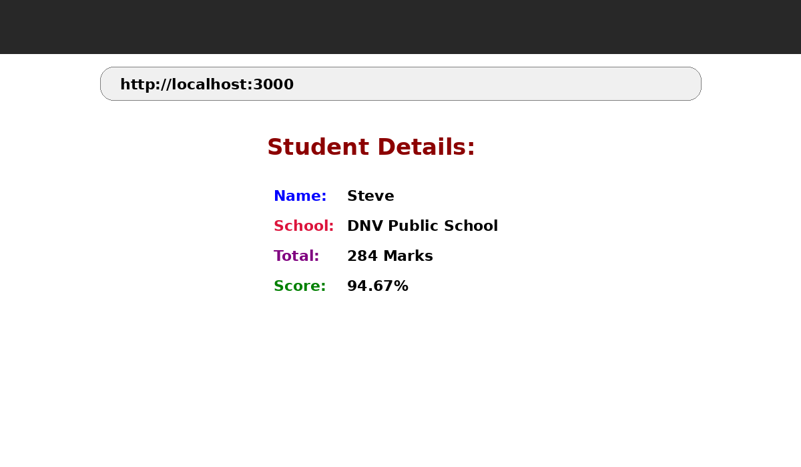

Conclusion
The application calculates and displays the student's score using a React functional component and CSS.

